- A website only allows users in the age bracket 18 to 21 inclusive to access its content. Write a method that accepts the age as an int argument and decides whether it is possible to access the site. Your method shall return a boolean value.

- Write a method that uses a switch statement to return the cost of a product, where the method receives a product description as a string argument.

The cost of each product is listed below:

Product Description | Cost
“Jeans” | 67.99
“Jacket” | 68.99
“Boots” | 34.99
“Scarves”,”Belts”,”Socks” | These are all 10
None of the above | Signal error with a cost of -999

- Write a method named Zero that accepts an int array as an argument and stores the value 0 in each element.

- Write a method:

static int Sum(int n1, int n2)

That returns the sum of all even numbers between the two integer arguments (inclusive) passed to it. For example:

Sum(2, 10) returns 30.

- Write a method that accepts a stock-on-hand figure and a sales figure as int arguments. It will update the stock-on-hand figure by deducting the sales figure if there is sufficient stock to fulfil the sale. The method shall return true if the stock-on-hand figure has been updated, otherwise false.

- Movie Ratings – 2D Array.
Create a 2D array which has movie ratings for 3 films. Each film has 3 reviews. Output the average rating for each film.
 | Reviewer 1 | Reviewer 2 | Reviewer 3
Film Title
Avengers Endgame | 3 | 4 | 5
Spider-Man: Far From Home | 1 | 2 | 1
Once Upon A Time in Hollywood | 5 | 4 | 2

- Movie Ratings – Jagged Array.
As above but this time there is a jagged array.
 | Reviewer 1 | Reviewer 2 | Reviewer 3 | Reviewer 4
Film Title
Avengers Endgame | 3 | 4
Spider-Man: Far From Home | 1 | 2 | 1 | 3
Once Upon A Time in Hollywood | 5 | 4 | 2

Use this code to define the jagged array
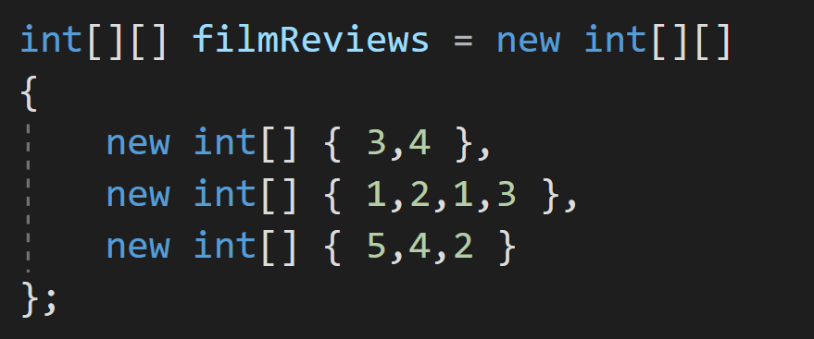

- Lists. Write a program which asks the user to enter the name of the players on the team. Use a sentinel value of -1. Store the names in a List<string> collection. Output the names of the team in alphabetical order to the screen.

- A program is required to read the sales data of a number of stores that is stored in a comma delimited file sales.txt. The program shall produce a report with the content and format outlined below. The performance description will be determined from the table below
Total_sales | Performance
<1000 | “Needs attention”
1000-1999 | “Moderate”
>2000 | “Very good”

The file has the following format: store_id, total_sales
For example, the file with the following data will result in the report below. You will have to make a test file in notepad with this data.
S1,500
S2,1200
S3,1800
S4,800
S5,1900

****expected report based on this test data***

Sales Report
Store ID Sales Performance
S1 500 Needs attention
S2 1200 Moderate
S3 1800 Moderate
S4 800 Needs attention
s5 2900 Very good
Total Sales 7,200
Average Sales : 1,440

